Ideation Phase
Define the Problem Statements

Date | 14 Feb 2026
Team ID | LTVIP2026TMIDS52481
Project Name | Dog Breed Identification using Transfer Learning
Maximum Marks | 2 Marks

Customer Problem Statement Template:
Diabetic retinopathy is a serious eye disease caused by prolonged diabetes and often remains undetected until it reaches an advanced stage, leading to irreversible vision loss. Early diagnosis is crucial for effective treatment and prevention of blindness; however, traditional screening methods are time-consuming, costly, and require specialized ophthalmologists and equipment.
This project aims to improve eye care by applying advanced deep learning techniques to predict diabetic retinopathy from retinal fundus images in a non-invasive manner. By identifying hidden patterns and abnormalities in retinal images, the system delivers accurate early-stage predictions, enabling timely medical intervention and supporting personalized, accessible, and cost-effective healthcare solutions.

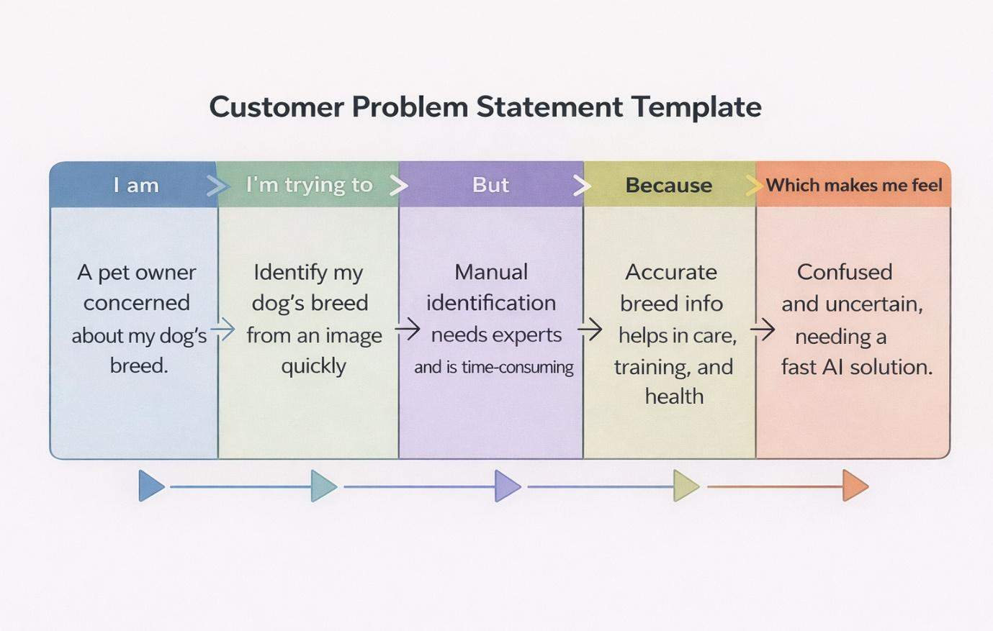

PS | I am (Customer) | I’m trying to | But | Because | Which makes me feel
PS-1 | A pet owner concerned about my dog’s breed and care | Identify my dog’s breed quickly using an image | Manual identification requires expert knowledge and takes time | Accurate breed recognition helps in proper training, nutrition, and healthcare | Confused and uncertain, needing a fast and reliable solution
PS-2 | A new pet adopter with little knowledge about dog breeds | Understand my dog’s characteristics and requirements | Online information is inconsistent and difficult to verify | Correct breed details are essential for grooming, feeding, and medical care | Worried and unsure about giving proper care
PS-3 | A veterinarian or pet service provider | Recognize dog breeds efficiently during consultation | Manual breed detection is slow and prone to human error | Automated AI prediction improves diagnosis speed and service efficiency | Frustrated and overloaded due to increasing workload
PS-4 | A dog enthusiast or researcher | Classify dog breeds automatically from images | Large datasets and visual similarity make manual classification difficult | Deep learning enables scalable, accurate, and consistent breed recognition | Motivated but limited without intelligent AI tools

